|  |  |
| --- | --- |
| *Pacific Gas and Electric Company* | |
|  | |
|  |  |
|  |  |
| Project | ED AM/GIS |
|  |  |
| Prepared by | Ashish Narasimham |
| Date | 8/28/2013 |
| Version | 1.1 |
| Version Type | Final |

|  |  |  |  |
| --- | --- | --- | --- |
| Revision History | | | |
| Document # | Date | Author | Summary of Changes |
| 1.0 | 8/21/13 |  | Initial Document Creation |
| 1.1 | 8/28/13 | Ashish Narasimham | Updated document to add PGEDATAMODELVERSION table |

# Introduction

## Purpose

This document is intended to detail the implementation and configuration steps required to implement the . This document describes the various configuration aspects required to complete any manual or automatic patch associated with this release. Each section in this document contains the steps required to patch the system in production.

## Terms Used

|  |  |
| --- | --- |
| OOTB | Out of the box. Unmodified from the commercial version. |
| TFS | Team Foundation Server |

## External Documents

Referenced are any external configuration documents or exports. These are documents that contain more detailed information about configuring a system or documents that can be loaded into an application to perform the configuration detailed in this document.

1. PGEDATAMODELVERSION table location:
2. \\sfetgis-nas01\sfgispoc_data\ApplicationDevelopment\IBM_TeamMembers\AshishNarasimham

## Summary of Steps to Complete Patch

These are the high-level steps to complete the installation and configuration of the data model patch. Use this table as a guide for completing the installation. Links are provided that can lead either within the document for detailed explanations or to external sites such as Sharepoint.

|  |  |  |  |
| --- | --- | --- | --- |
|  | **Step Name** | **Description** | **CR (if applicable)** |
|  | Master WIP Data Model Release 2.0 | Master for all changes going into the WIP 2.0 release | [9548](http://edappgistfsprd1:8080/tfs/ElectricDistCollection/EDAMGIS/_workItems#_a=edit&id=9548) |
|  | Open a Database Connection in ArcCatalog | Open a connection in ArcCatalog to the target SDE database | - |
|  | Change TEXTVALUE Field Length In RedlineText Feature Class | Drop and re-create the TEXTVALUE field to increase its size from 50 to 2000 | [9552](http://edappgistfsprd1:8080/tfs/ElectricDistCollection/EDAMGIS/_workItems#_a=edit&id=9552) |
|  | Change JOBNUMBER field to INSTALLJOBNUMBER in WEBR | Drop and re-create the Job Number field in the WIP data model to change its name to InstallJobNumber | [9402](http://edappgistfsprd1:8080/tfs/ElectricDistCollection/EDAMGIS/_workItems#_a=edit&id=9402) |
|  | Copy PGEDATAMODELVERSION table into Instance | Copy the PGEDATAMODELVERSION table from the Shared drive into the instance | - |

# Open a Database Connection in ArcCatalog

1. Open ArcCatalog.
2. Within the Catalog Tree, expand “Database Connections” and open the active connection for this process. This is the connection that is referenced in the change request associated with this document (EDGIS<DB name in the format X#Y> )

# Change Size Of TEXTVALUE Field In WIP RedlineText Feature Class

* 1. Expand the Redlines dataset, select the RedlineText feature class, right click, and select Properties  
     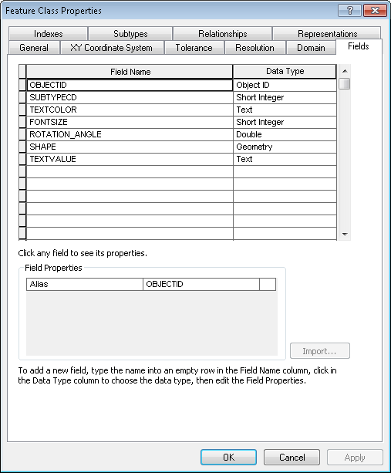
  2. Click the fields tab and scroll down to the TEXTVALUE field  
     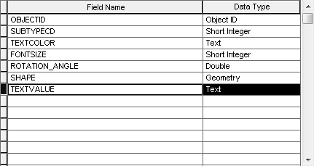
  3. Highlight the field and press the Delete key to delete it
  4. Select the empty area below the last field to create a new field
  5. Type in the field’s name, ‘TEXTVALUE’ and set the field type to Text
  6. Click the field properties mini-window below and set the field length to 2000

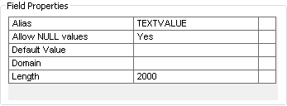

# Change The JobNumber Field To InstallJobNumber

1. At the root level of the database, find the PGE_PMORDER_WIP relationship class. Select it, right click, and click Delete
2. Navigate to the WIP feature class under the WIPRedlines dataset, right click, and select Properties
3. In the Fields tab, scroll down to the bottom and click in the empty space below the last field to create a new field
4. Create a new field titled INSTALLJOBNUMBER of type Text with length 14 (specified in the Field Properties window below)  
   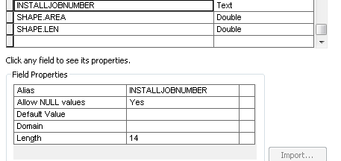
5. Navigate to the PGE_PMORDER feature class under the root level and open its Properties
6. Create a new field at the bottom of the Fields tab called INSTALLJOBNUMBER of type Text with length 14
7. Open a command line prompt, log into the same database as WEBR, and run the following four SQL commands:  
     
   UPDATE WEBR.WIP set INSTALLJOBNUMBER = JOBNUMBER;

commit;

UPDATE WEBR.PGE_PMORDER set INSTALLJOBNUMBER = JOBNUMBER;

commit;

1. Open the WIP feature class under the WIPRedlines dataset, go to the Fields tab, select the JOBNUMBER field, and press Delete to delete the field
2. Do the same for the JOBNUMBER field in the PGE_PMORDER feature class
3. At the root level, right click in the empty area on the right pane and select New->Relationship Class
4. Fill out the screens according to the following screenshots. You should end up with the following properties: WEBR.PGE_PMORDER_WIP (1-M) Origin PGE_PMORDER, Destination WIP, with primary key and foreign key being INSTALLJOBNUMBER.  
   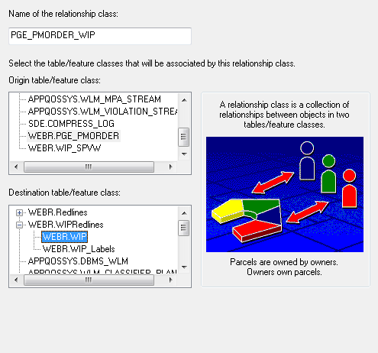  
   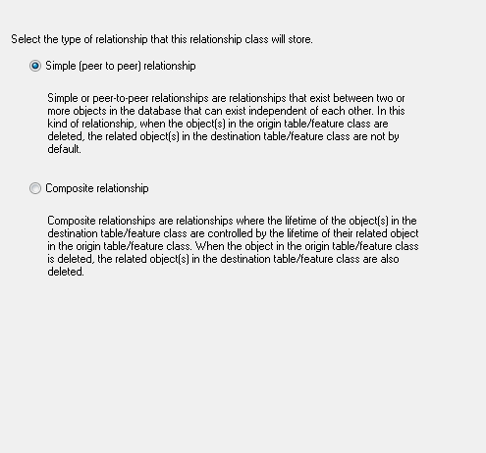

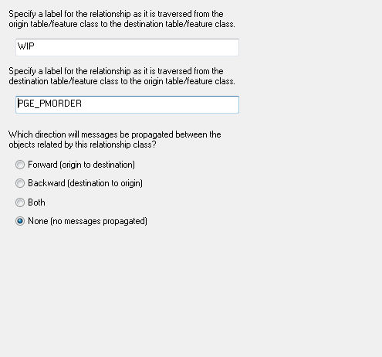  
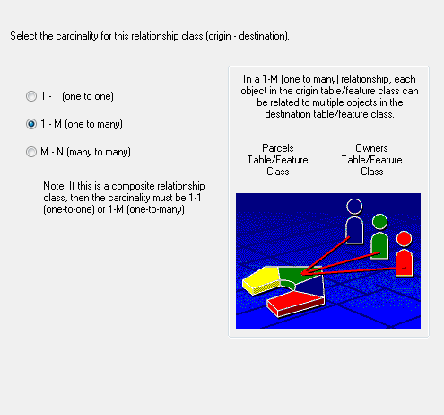  
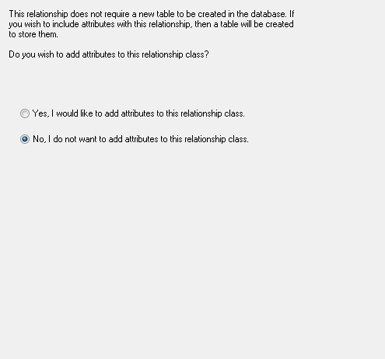  
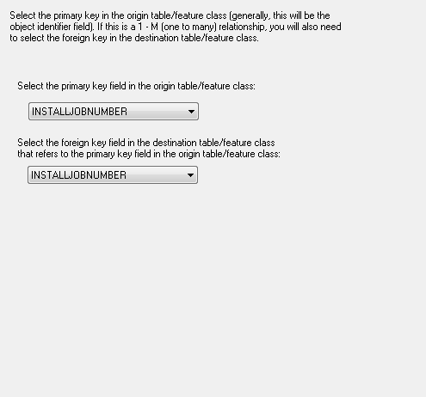  
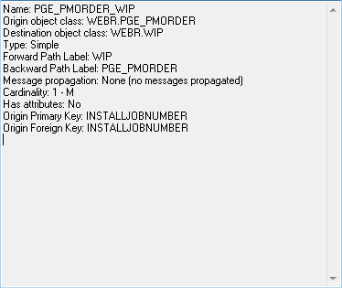

1. Click Finish to create the relationship class
2. Run the following script from the command line, making sure to change the instance name and password at the end of the script to the appropriate values for the database:   
     
   sdetable -o create_view -T WIP_SPVW -t "WIP,PGE_PMOrder" -c "WIP.OBJECTID,WIP.MLXNUMBER,WIP.INSTALLJOBNUMBER,WIP.DESCRIPTION,WIP.ORDERCREATIONDATE,WIP.ESTIMATORLANID,WIP.JOBOWNERLANID,WIP.LOCATIONNUMBER,WIP.DATECREATED,WIP.DATEMODIFIED,WIP.DESIGNTYPE,WIP.DESIGNREVISIONNUMBER,WIP.BUFFERAREA,WIP.SERVICEPROVIDER,WIP.UTILITYTYPE,WIP.SUBTYPECD,PGE_PMORDER.INSTALLJOBNUMBER,PGE_PMORDER.JOBOWNERLANID,PGE_PMORDER.LASTMESSAGEDATE,PGE_PMORDER.MAT,PGE_PMORDER.ORDERCREATEDATE,PGE_PMORDER.DIVISION,PGE_PMORDER.EQUIPMENT,PGE_PMORDER.FUNCTIONLOCATION,PGE_PMORDER.JOBDESCRIPTION,PGE_PMORDER.JOBTYPE,PGE_PMORDER.LEGACYMAPNUMBER,PGE_PMORDER.MAINWORKCENTER,PGE_PMORDER.REGION,PGE_PMORDER.USERSTATUS,PGE_PMORDER.WORKTYPE,PGE_PMORDER.WIPFOUND,PGE_PMORDER.WIPMISSING,WIP.SHAPE" -a "OBJECTID,MLXNUMBER,INSTALLJOBNUMBER,DESCRIPTION,ORDERCREATIONDATE,ESTIMATORLANID,JOBOWNERLANID,LOCATIONNUMBER,DATECREATED,DATEMODIFIED,DESIGNTYPE,DESIGNREVISIONNUMBER,BUFFERAREA,SERVICEPROVIDER,UTILITYTYPE,SUBTYPECD,SAPJOBNUMBER,SAPJOBOWNERLANID,LASTMESSAGEDATE,MAT,ORDERCREATEDATE,SAPDIVISION,SAPEQUIPMENT,SAPFUNCTIONALLOCATION,SAPJOBDESCRIPTION,SAPJOBTYPE,SAPLEGACYMAPNUMBER,SAPMAINWORKCENTER,SAPREGION,SAPUSERSTATUS,SAPWORKTYPE,WIPFOUND,WIPMISSING,SHAPE" -w "WIP.INSTALLJOBNUMBER = PGE_PMORDER.INSTALLJOBNUMBER" -s edgisdboraqa02 -i sde:oracle11g:/;local=edgisw1d -u webr -p webr
3. Run the following script from an SQL prompt after logging in as the WEBR user to the target SDE database:  
     
    CREATE OR REPLACE FORCE VIEW "WEBR"."WIP_SPVW" ("OBJECTID", "MLXNUMBER", "INSTALLJOBNUMBER", "DESCRIPTION", "ORDERCREATIONDATE", "ESTIMATORLANID", "JOBOWNERLANID", "LOCATIONNUMBER", "DATECREATED", "DATEMODIFIED", "DESIGNTYPE", "DESIGNREVISIONNUMBER", "BUFFERAREA", "SERVICEPROVIDER", "UTILITYTYPE", "SUBTYPECD", "SAPJOBNUMBER", "SAPJOBOWNERLANID", "LASTMESSAGEDATE", "MAT", "ORDERCREATEDATE", "SAPDIVISION", "SAPEQUIPMENT", "SAPFUNCTIONALLOCATION", "SAPJOBDESCRIPTION", "SAPJOBTYPE", "SAPLEGACYMAPNUMBER", "SAPMAINWORKCENTER", "SAPREGION", "SAPUSERSTATUS", "SAPWORKTYPE", "WIPFOUND", "WIPMISSING", "SHAPE") AS

SELECT WIP.OBJECTID, WIP.MLXNUMBER, WIP.INSTALLJOBNUMBER, WIP.DESCRIPTION, WIP.ORDERCREATIONDATE, WIP.ESTIMATORLANID, WIP.JOBOWNERLANID, WIP.LOCATIONNUMBER, WIP.DATECREATED, WIP.DATEMODIFIED, WIP.DESIGNTYPE, WIP.DESIGNREVISIONNUMBER, WIP.BUFFERAREA, WIP.SERVICEPROVIDER, WIP.UTILITYTYPE, WIP.SUBTYPECD, PGE_PMORDER.INSTALLJOBNUMBER, PGE_PMORDER.JOBOWNERLANID, PGE_PMORDER.LASTMESSAGEDATE, PGE_PMORDER.MAT, PGE_PMORDER.ORDERCREATEDATE, PGE_PMORDER.DIVISION, PGE_PMORDER.EQUIPMENT, PGE_PMORDER.FUNCTIONLOCATION, PGE_PMORDER.JOBDESCRIPTION, PGE_PMORDER.JOBTYPE, PGE_PMORDER.LEGACYMAPNUMBER, PGE_PMORDER.MAINWORKCENTER, PGE_PMORDER.REGION, PGE_PMORDER.USERSTATUS, PGE_PMORDER.WORKTYPE, PGE_PMORDER.WIPFOUND, PGE_PMORDER.WIPMISSING, WIP.SHAPE FROM WEBR.WIP LEFT OUTER JOIN WEBR.PGE_PMORDER ON WIP.INSTALLJOBNUMBER = PGE_PMORDER.INSTALLJOBNUMBER;

# Copy PGEDATAMODELVERSION table into Instance

1. Openthe location referenced in section 1.3 – External Documents – through ArcCatalog. If necessary, create a folder connection by right clicking Folder Connections and clicking Connect Folder.
2. Drag and drop the PGEDATAMODELVERSION table from that location into the target SDE database.
3. Right click the PGEDATAMODELVERSION table and click Privileges.
4. Set the following privileges:

|  |  |  |
| --- | --- | --- |
| Role | View | View & Edit |
| SDE_EDITOR |  | X |
| SDE_VIEWER | X |  |
| DAT_EDITOR | X |  |
| **DATACONV | X |  |

1. To do this, type each user name into the ‘User’ prompt and select GRANT for the appropriate dropdown (either View or Edit).  
   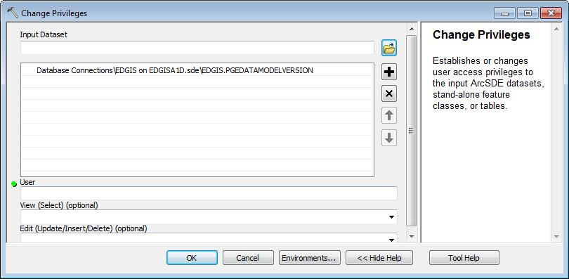

# Known Issues

<Please List any other issues encountered here while following the document>